April 28, 2023

MobileOS User documentation

COSC7391C_ICTPRG430 – Apply introductory object-oriented language skills.

Michael mariani(S4002416)

# Table of Contents

|  |  |
| --- | --- |
| 1. Section 1    1. Sub-Section 1.1    2. Sub-Section 1.2    3. Sub-Section 1.3    4. Sub-Section 1.4    5. Sub-Section 1.5    6. Sub-Section 1.6 2. Section 2    1. Sub-Section 2.1    2. Sub-Section 2.2 3. Section 3    1. Sub-Section 3.1    2. Sub-Section 3.2 4. Section 4 | Page 3  Page 3  Page 3  Page 3  Page 3  Page 3  Page 3  Page 4  Page 4  Page 4  Page 5  Page 5  Page 5  Page 6 |

# Software Instructions

## Language

Programming Language used : Python3

## Where to get python?

Python3 can be downloaded from www.python.org

## IDE for running application

There is no other requirements for running this program, all that is needed is the python framework installed on the PC. But for this project VSCode has been used to create and edit the program.

## Where to download VSCode

<https://code.visualstudio.com/download> is where VSCode can be downloaded from

## OS Requirements

This program can be run on any device that has python installed, no OS restrictions.

## How to run the application

Right click the ‘MobileOS.py’ file and Open with VSCode, otherwise to run the program independently it can just be double clicked and it will run(so long as python3 is installed).

# Software Inputs and Outputs

## Valid Inputs for this application

When using this application, you will first be prompted for a menu selection. Only the numbers 1 through 4 will be accepted into this, otherwise an error will display and you will be prompted again.

OPTION 1 – If you have selected option 1, which is the ‘Make a Call’ option. A valid input for this menu option will be a 10 digit number, starting for 04. Anything else will not be accepted and the user will be displayed an error.

OPTION 2 – After selecting option 2 you will be prompted to enter an email address. A valid email address consists of a string ending in “@gmail.com” and not containing any more than 1 @ symbol.

OPTION 3 – Doesn’t take an input, but charges the battery.

OPTION 4 – Closes the application.

## Valid Outputs

Make a call valid output

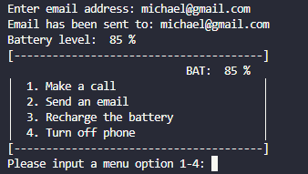Valid Email output

Option 3

# Software Troubleshooting

## Invalid Input handling

Invalid Menu option selection

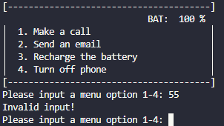

You must input a selection from the menu option, this being a number between 1 and 4 inclusive.

Invalid phone number

A phone number must start with ‘04’ and consist of 10 numbers.

Invalid email

An email must end in ‘@gmail.com’

And not contain more than one @ symbol.